FOR IMMEDIATE RELEASE:

Making A Painting: The Blue Tarp Project
Joseph Fontinha
August 30 – September 3
Opening Reception: Friday, September 1, 2017 | 5:00 p.m. - 9:00 p.m.

FOR PRESS-READY IMAGES CONTACT: Marie Craig fountainstfineart@gmail.com, (774) 286-1800

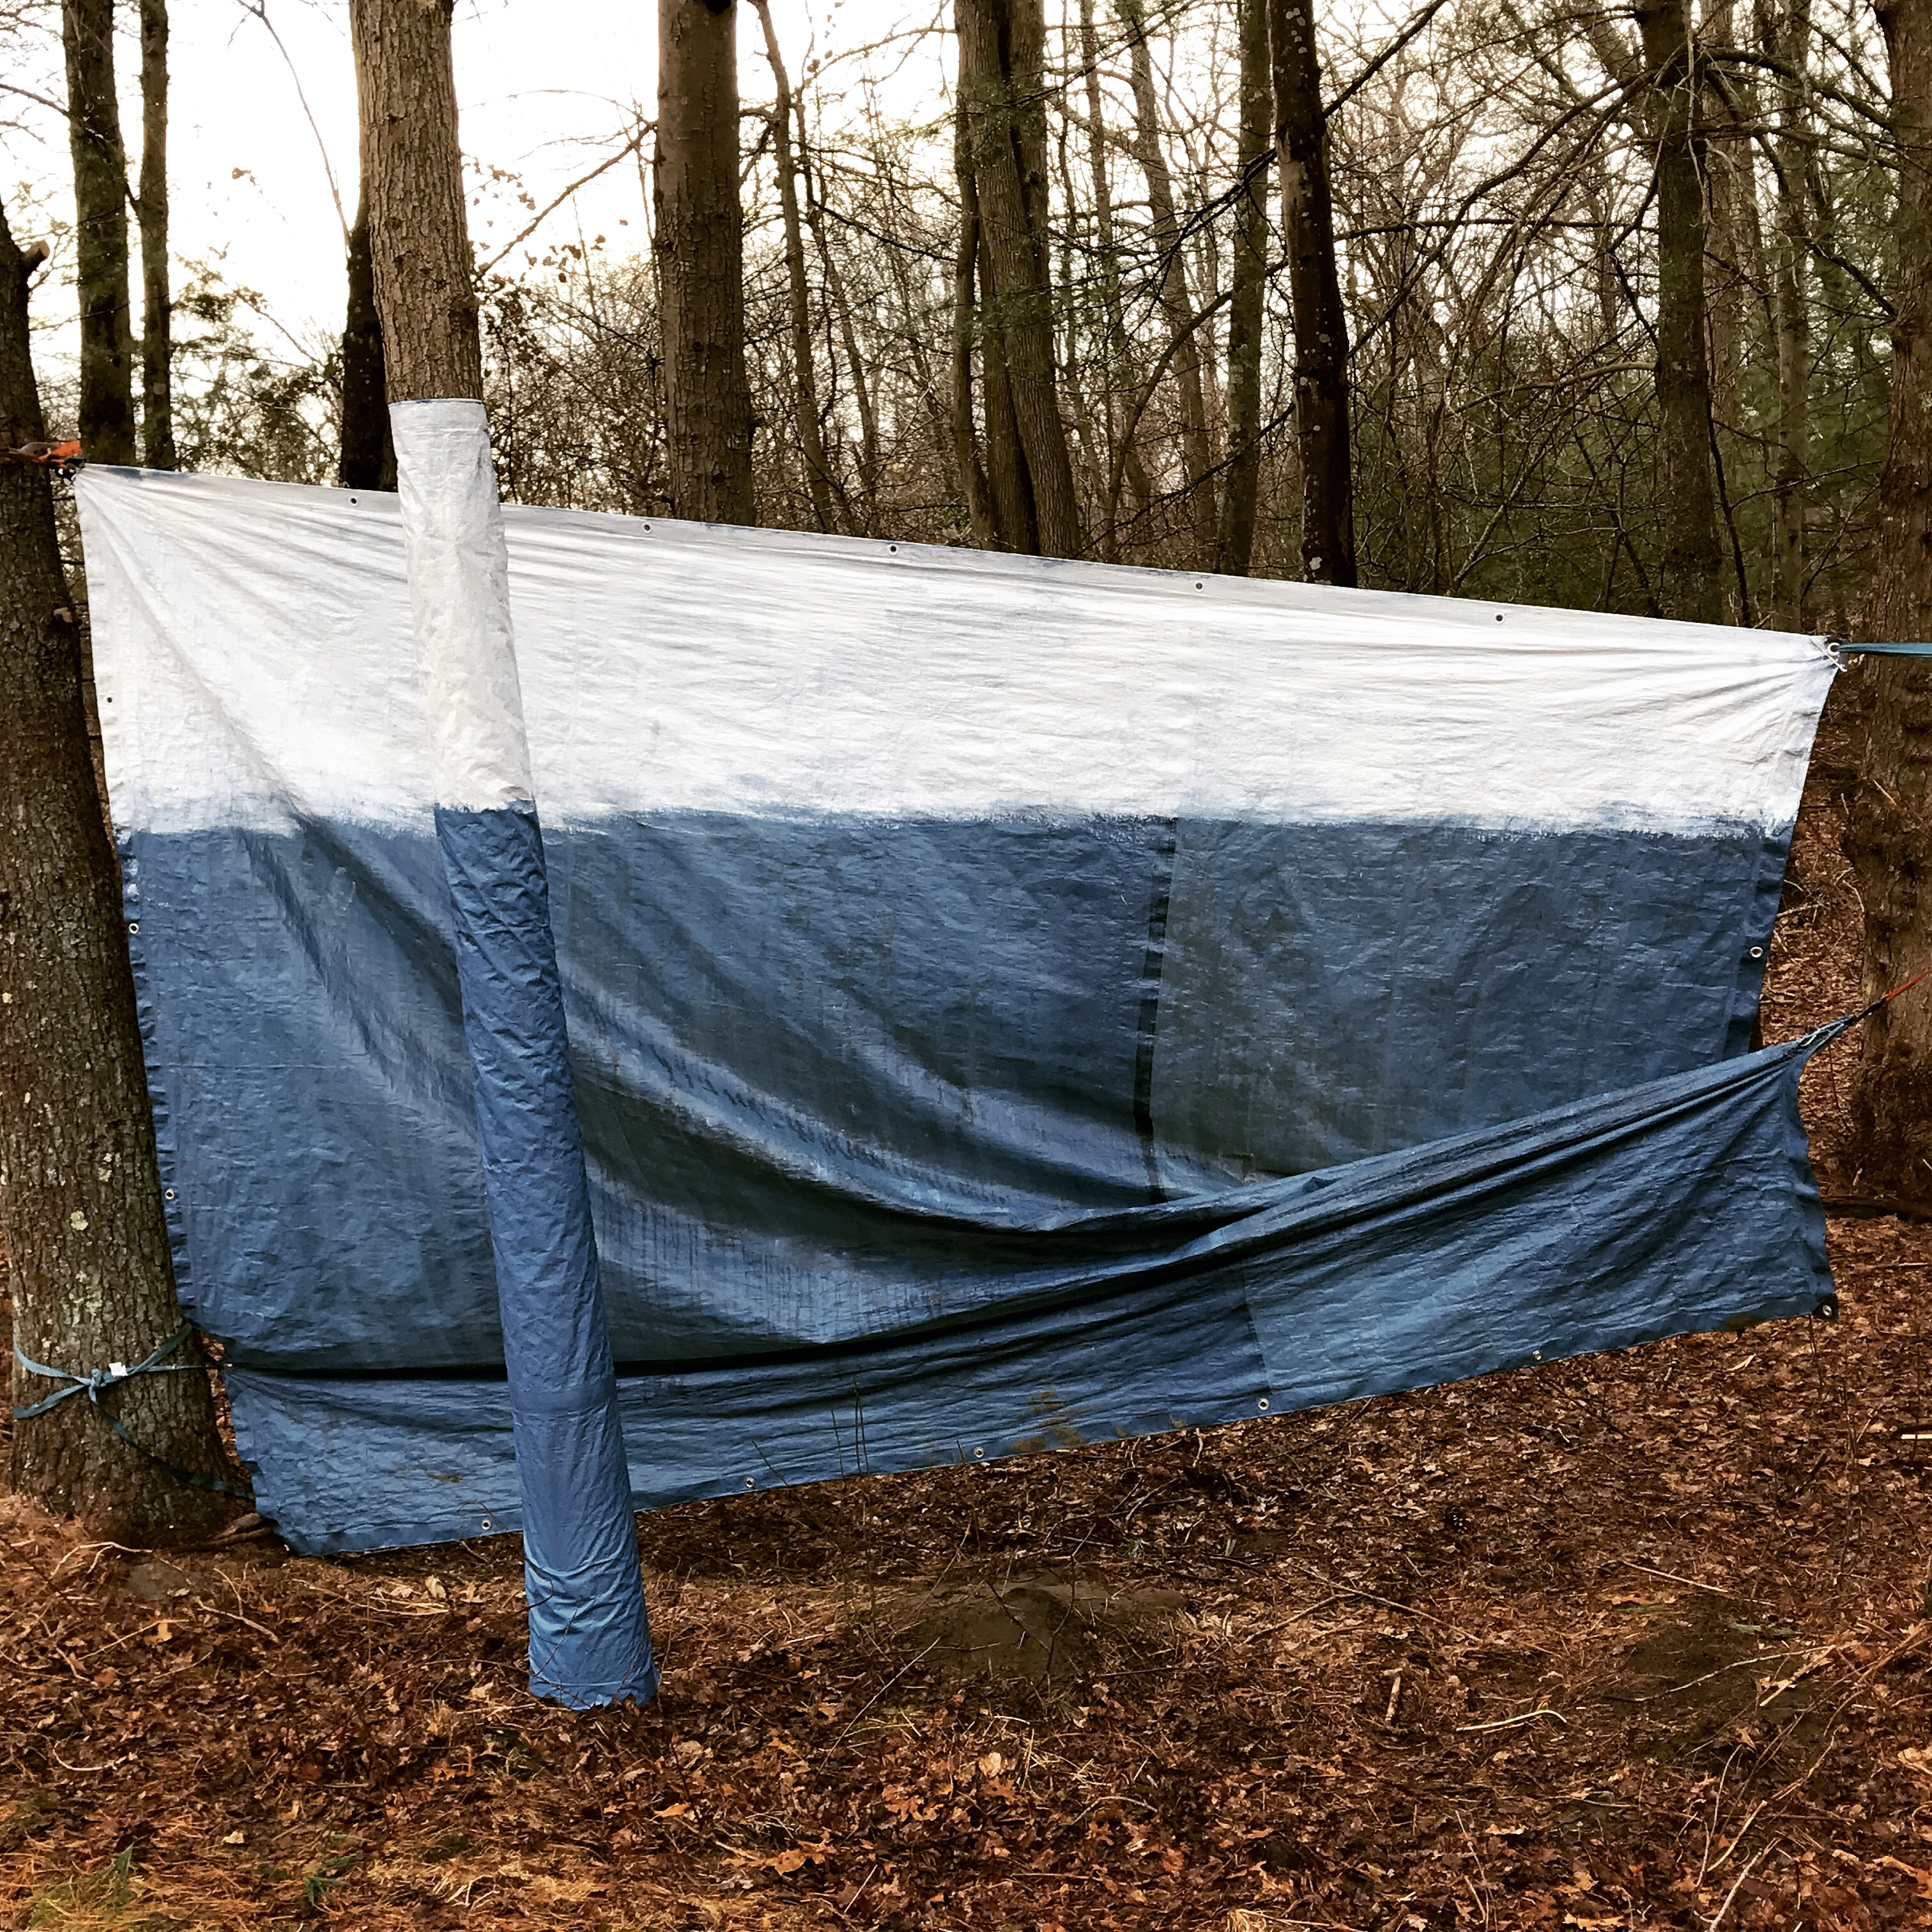

BOSTON, MA – Beginning August 30th, Fountain Street gallery opens its first Pop-Up exhibit: "Making a Painting: The Blue Tarp Project,” featuring the work of Joseph Fontinha. The show highlights a variety of recent projects from the artist’s work, including painting, drawing, installation, video, and studio recreation. Several portions of Joseph’s recent work from The Blue Tarp Project, Blue Box Theater, and Fake Studio will be exhibited and the artist himself will be re-creating his studio experience as a live part of the exhibit. For a few days Fountain Street Gallery will be his studio as he explores art’s potential in capturing truly authentic experience.

Joseph Fontinha was trained and educated as an oil painter, but of late has been expanding what he does from oil painting to a combination of video, installation, and performance based work that is all residual of painting, but tells a broader story, and one that holds the viewers attention in a different way. In all mediums Joseph’s work offers a forensic re-tracing of his steps as a maker. Once a painter that made pictures of objects, he is now working on projects that showcase his own working lifestyle and ideas, all the while keeping at the forefront a studio-centric, idea-driven, spontaneous and visceral approach to solving visual problems. Joseph has been moving away from the commodification of his work, the making of objects for sale, to telling stories through processes, and then figuring out what is salvageable from the project that can be shared. He is interested in the relationship between artist and viewer, and the connection between personal and human stories.

Fontinha received his MFA in Visual Studies from the Lesley University (LUCAD), a MA in Art Education from Boston University, and a BFA in Studio Art from Massachusetts College of Art and Design. His work has been exhibited at numerous galleries. Joseph is a Core Member of Fountain Street Gallery and currently lives on the South Coast, Massachusetts with an artist studio located in his home.

“Making a Painting: The Blue Tarp Project” will run from August 30th through September 3rd. The Gallery is located at 460c Harrison Ave. #2, Boston, MA and is open Wednesday through Sunday from 11am to 5pm, or by appointment.

Schedule of events:
September SoWa First Friday Reception - Friday, September 1, 2017 5:00-9:00pm

Fountain Street, a resource for artists, art-lovers and collectors, is a contemporary gallery in Boston, MA that exhibits the artwork of twenty-two emerging and mid-career artists.

Image information: Joseph Fontinha, Installation, Gesso on Tarp

Contact: Marie Craig (774) 286-1800
Fountain Street, 460c Harrison Ave. #2, Boston, MA 02118
GALLERY HOURS Wed-Sun, 11-5 and by appointment (617) 292-4900
*Starting in September 2017 Gallery Hours: Wed-Sun, 12-6 and by appointment
fountainstfineart@gmail.com fsfaboston.com

