$
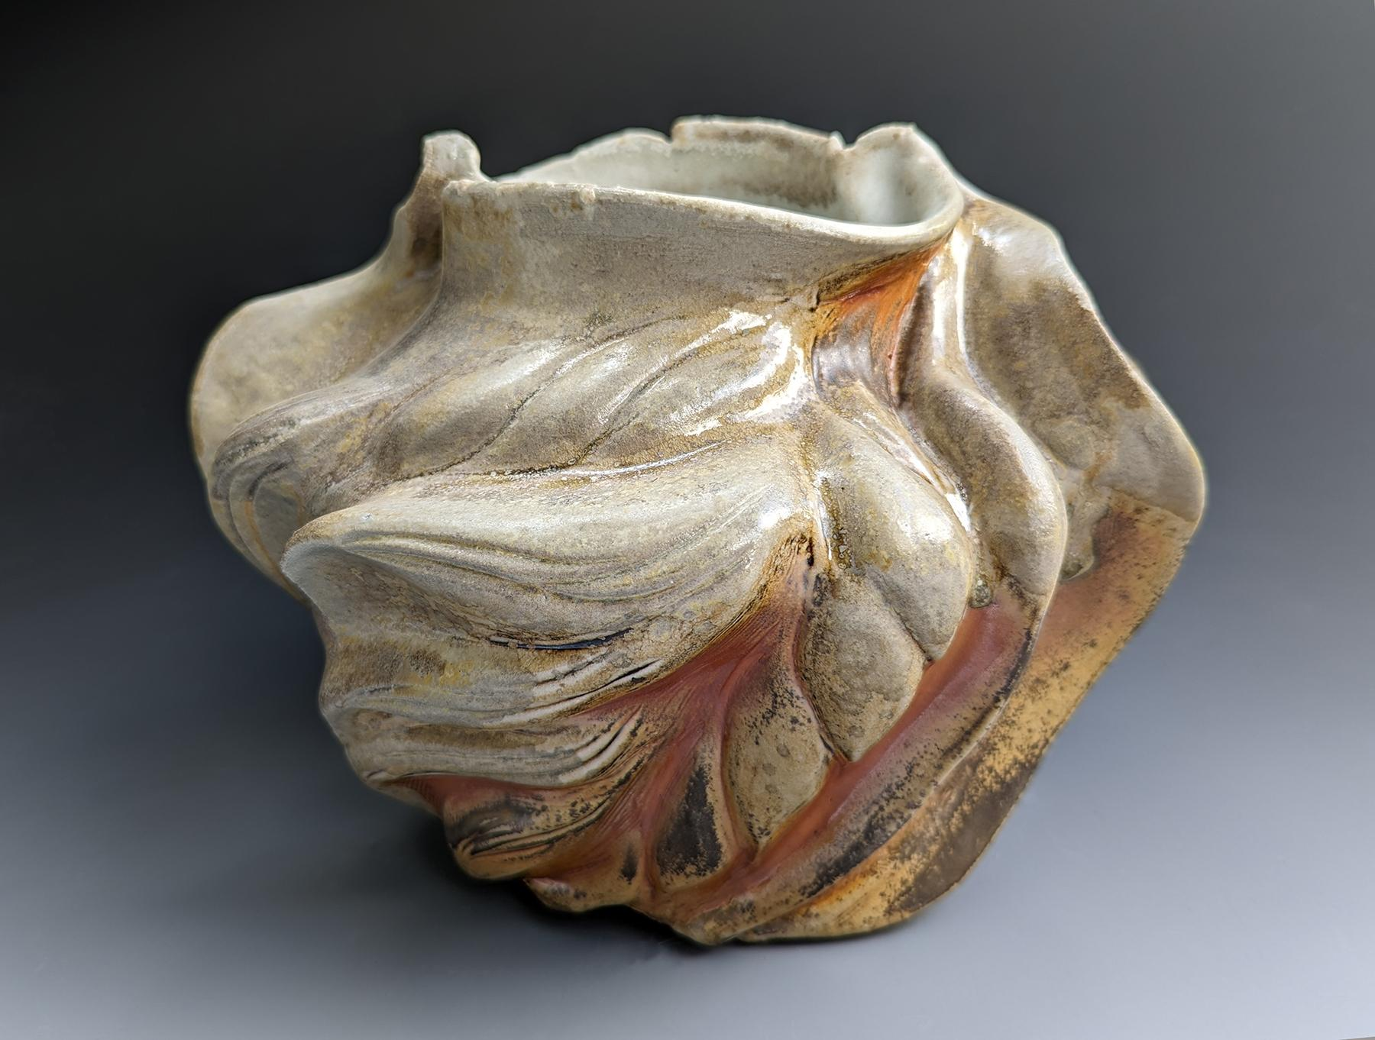 | Heather Binder  Ashy Wave Vase (view 1)  wood-fired ceramics  8 x 10 x 8 inches  $1100
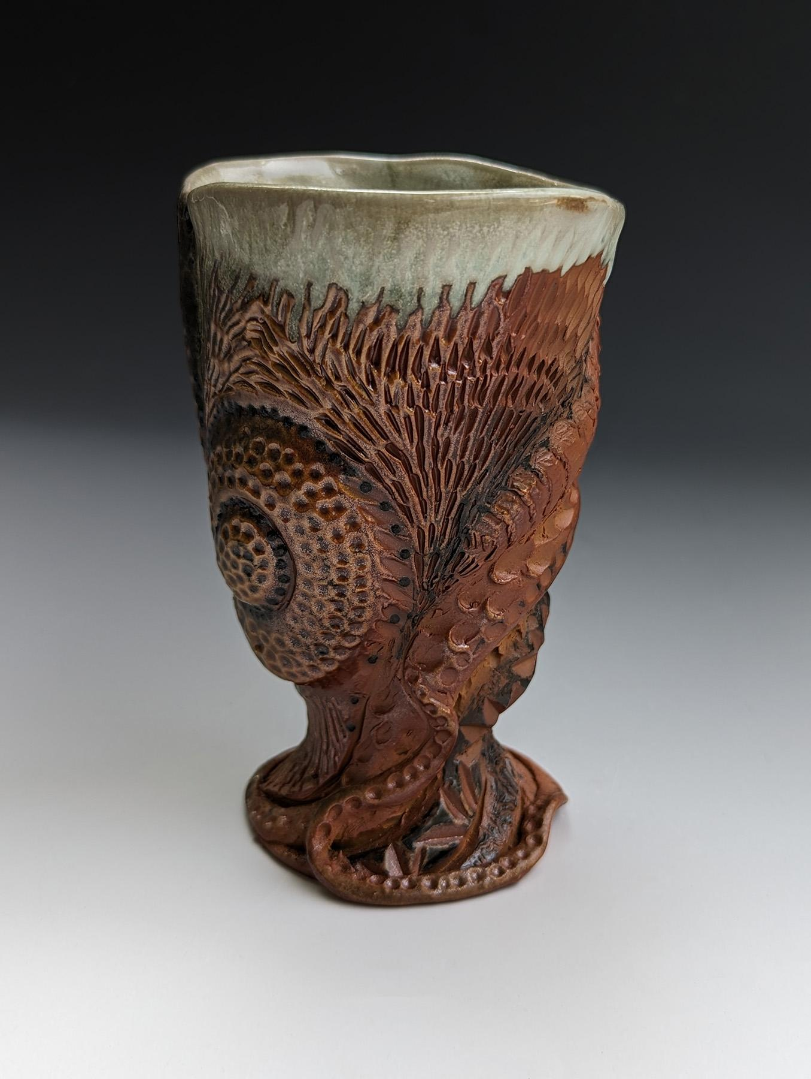 | Heather Binder  Carved Cup # 2  wood-fired ceramics  5 x 4 x 4 inches  $135.00
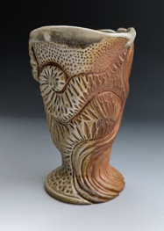 | Heather Binder  Carved Cup # 1  wood-fired ceramics  5 x 3.5 x 5 inches  $135.00
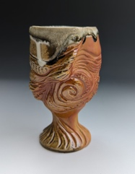 | Heather Binder  Carved Wine Cup  wood-fired ceramics  5 x 3.5 x 5 inches  $135.00
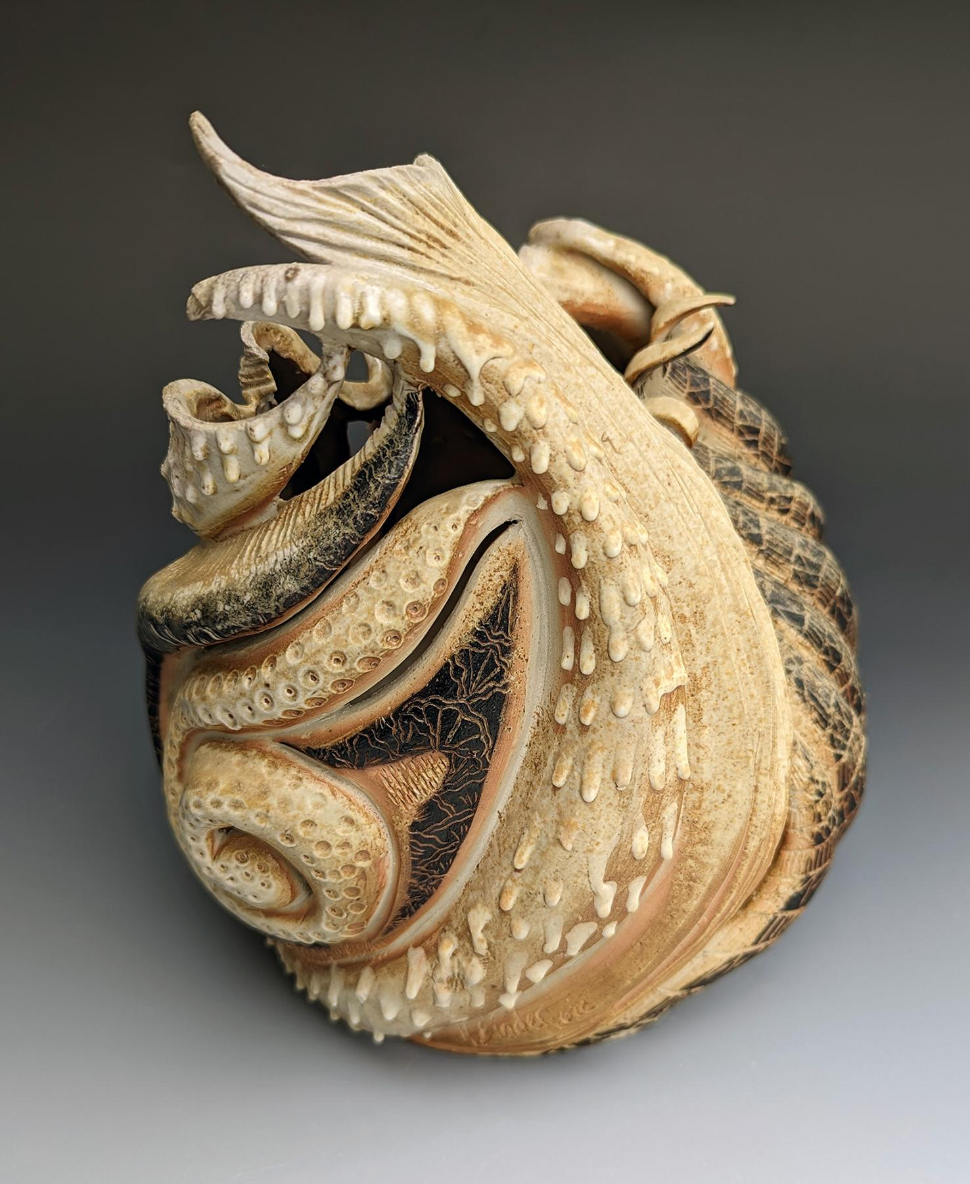 | Heather Binder  Deep Dive  wood-fired ceramics  9.5 x 8 x 7 inches  $1200
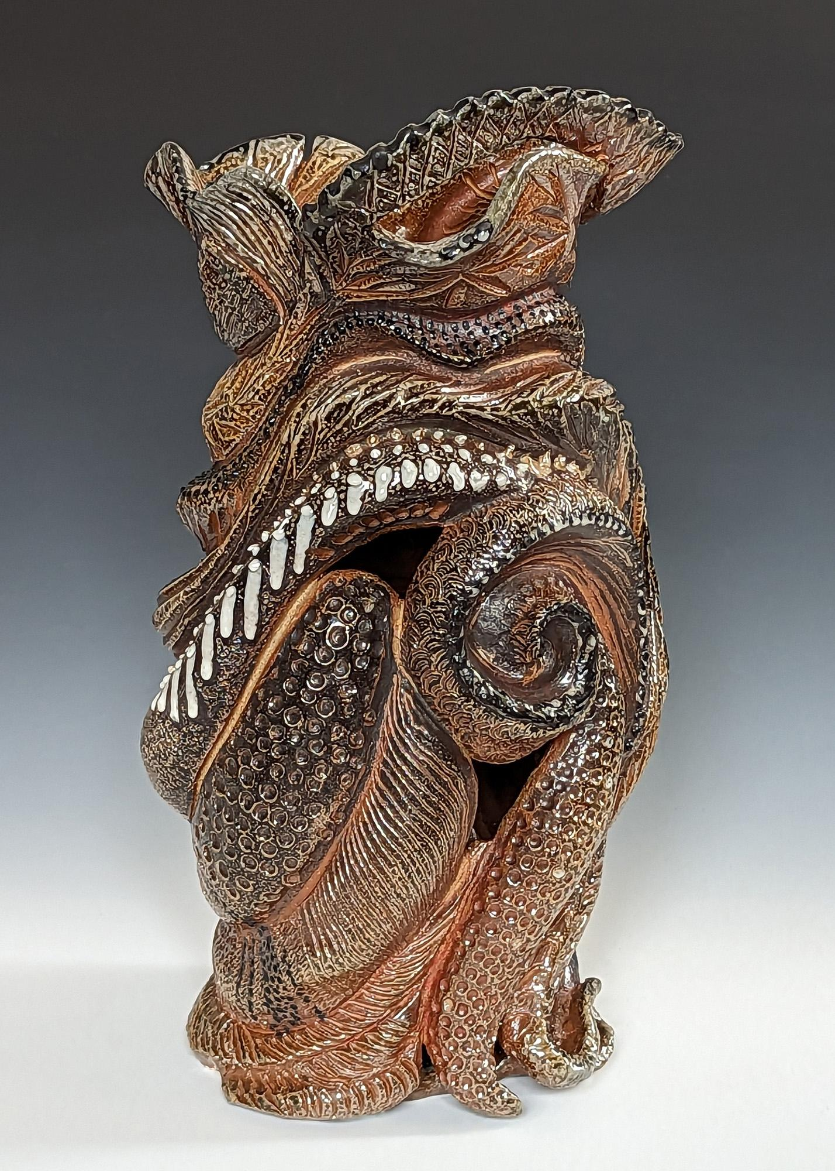 | Heather Binder  wood-fired ceramics  Dressed for the Ball  9.5 x 8 x 7 inches  $1500
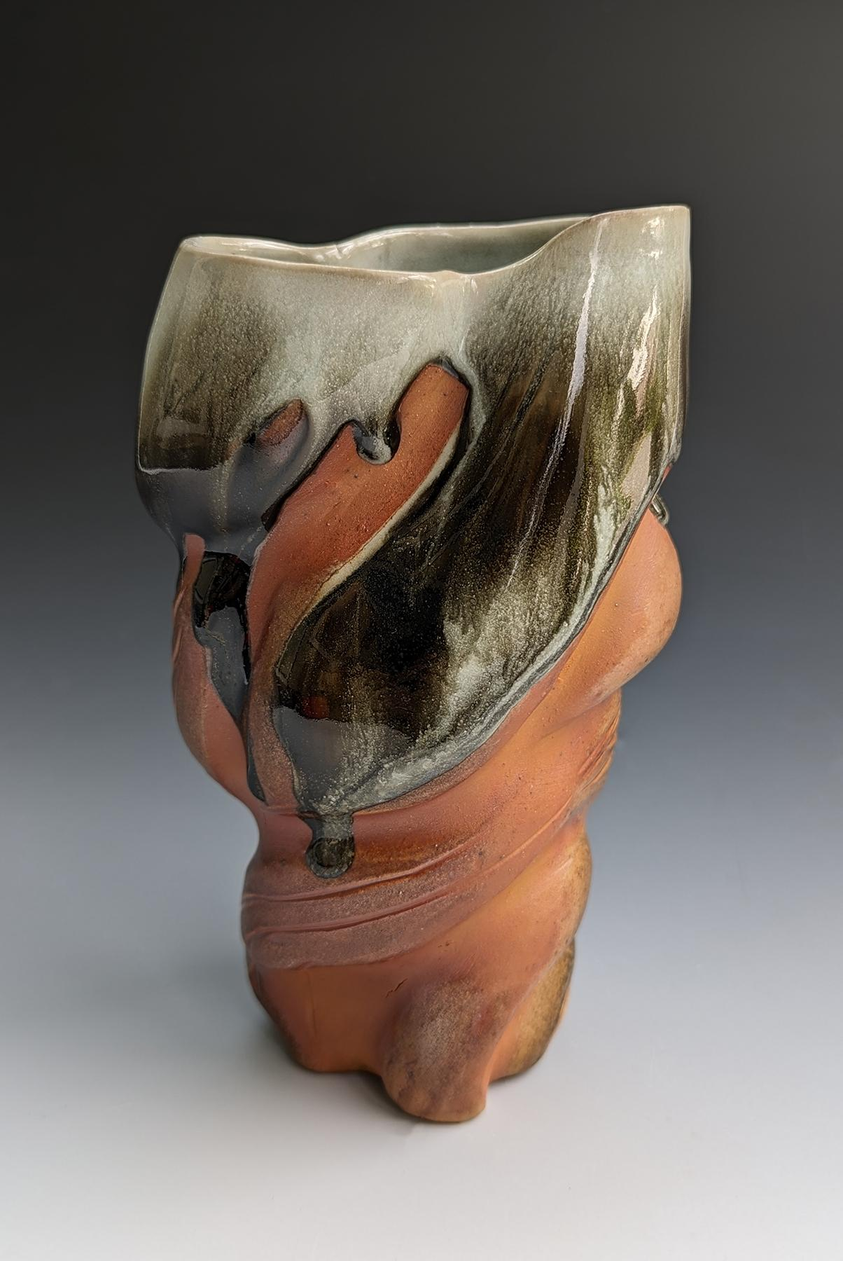 | Heather Binder  wood-fired ceramics  Fire and Ice  8 x 5 x 4 inches  $900
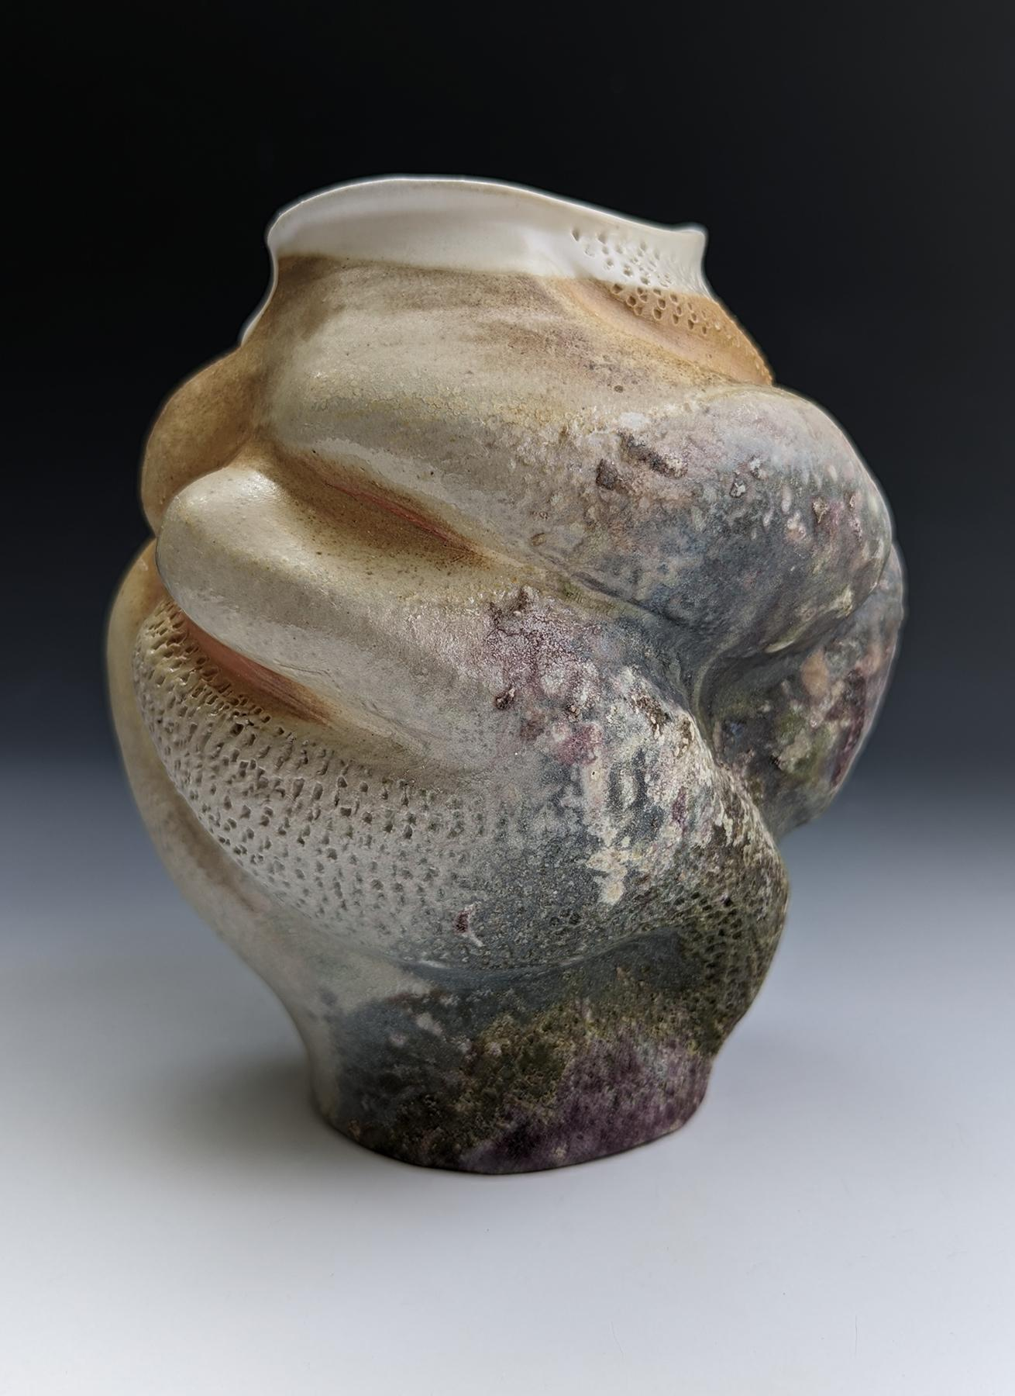 | Heather Binder  Reef Vase  wood-fired ceramics  7 x 5 x 4 inches  $850
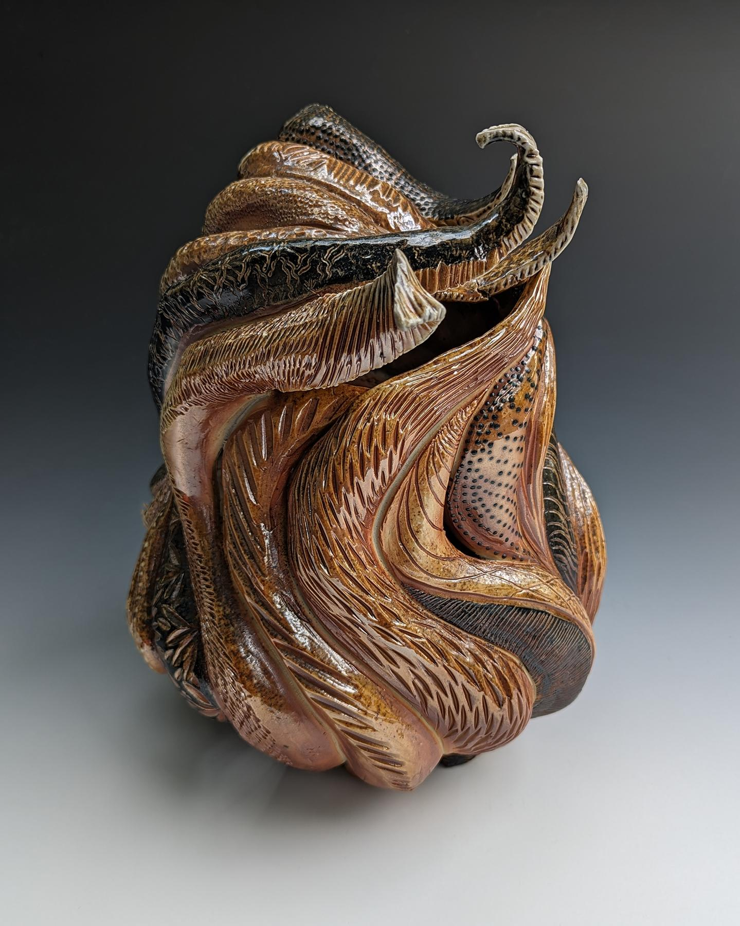 | Heather Binder  Textured Wave Sculpture  wood-fired ceramics  12 x 8 x 9 inches  $2500
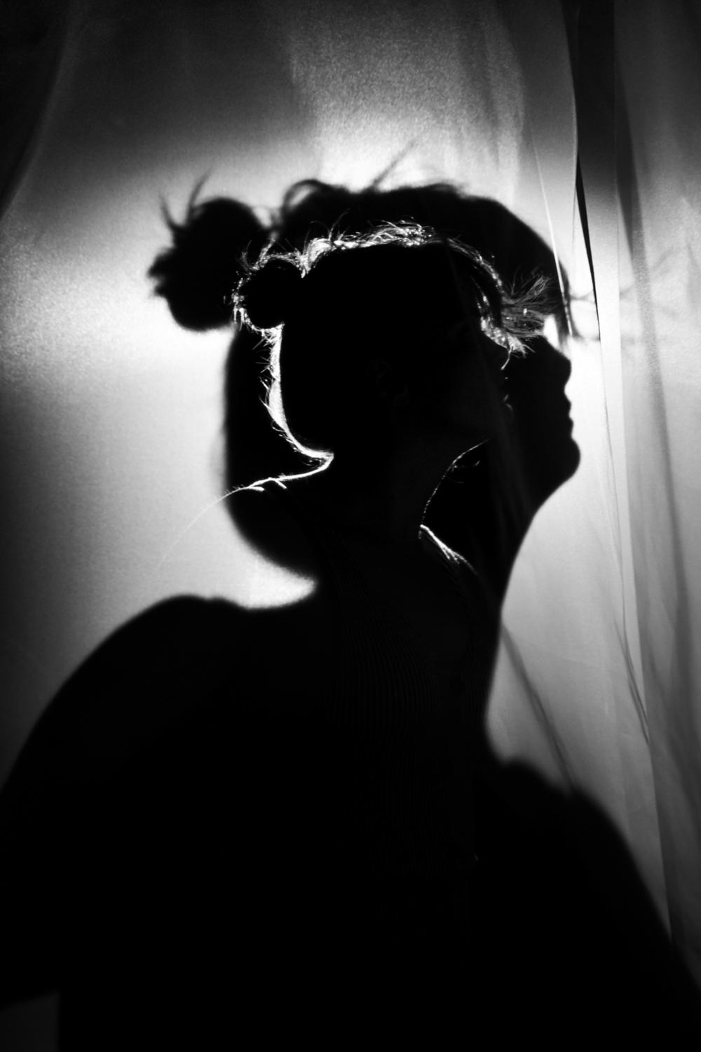 | Jaina Cipriano  Echoes  photograph in built environment  16 x 20 inches  $750
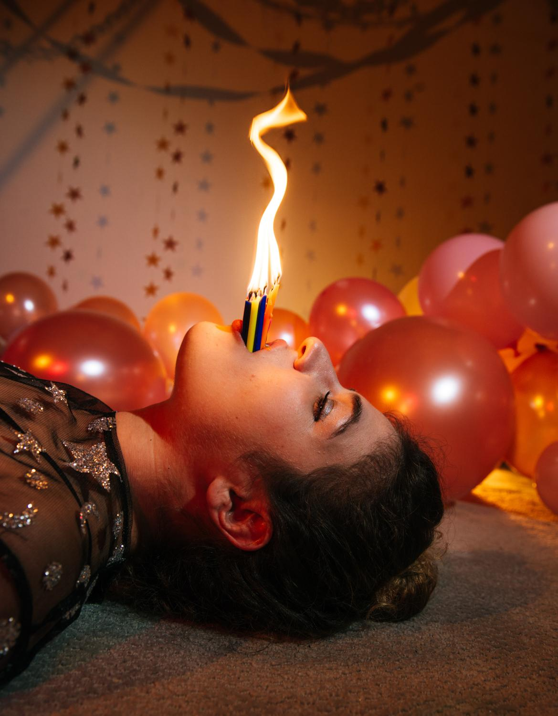 | Jaina Cipriano  One More Year  photograph in built environment  16 x 20 inches  $750
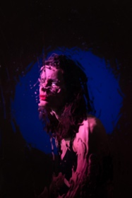 | Jaina Cipriano  Blurred Lines  photograph in built environment  13.5 x 20 inches  $750
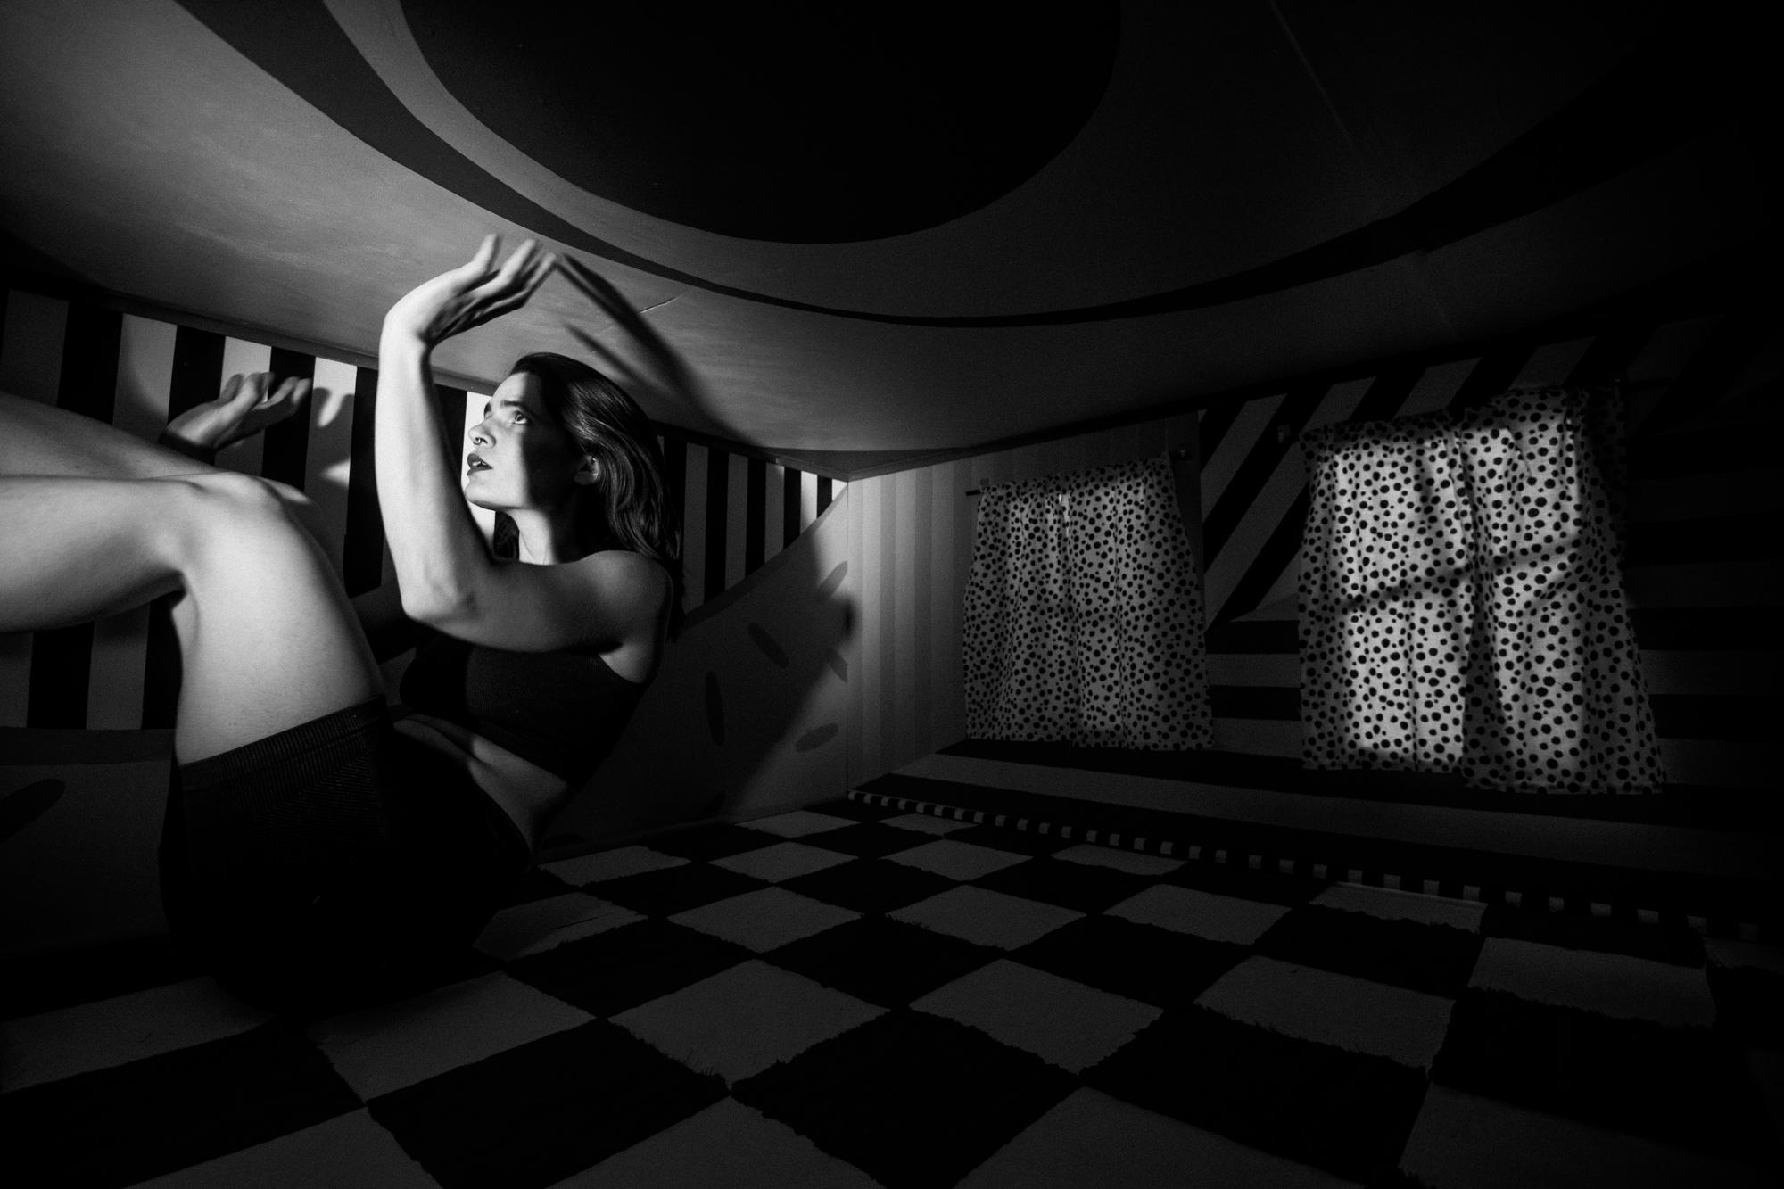 | Jaina Cipriano  Unsteady  photograph in built environment  16.5 x 24.5 inches  $750
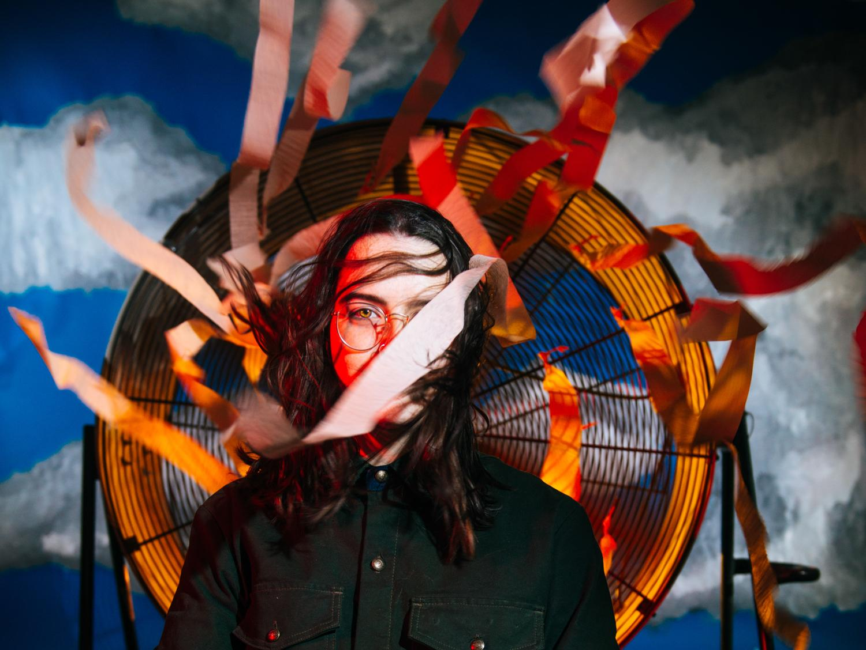 | Jaina Cipriano  Untitled  photograph in built environment  18 x 24 inches  $750
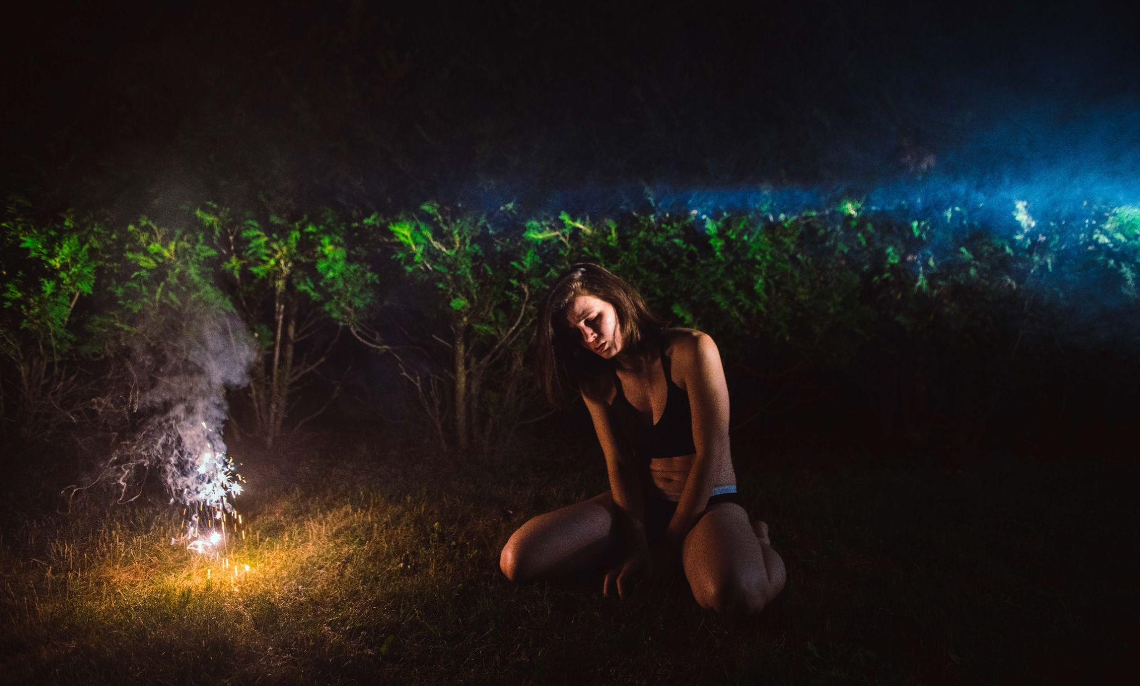 | Jaina Cipriano  What’s Left to Celebrate?  photograph in built environment  16.5 x 24.5 inches  $750
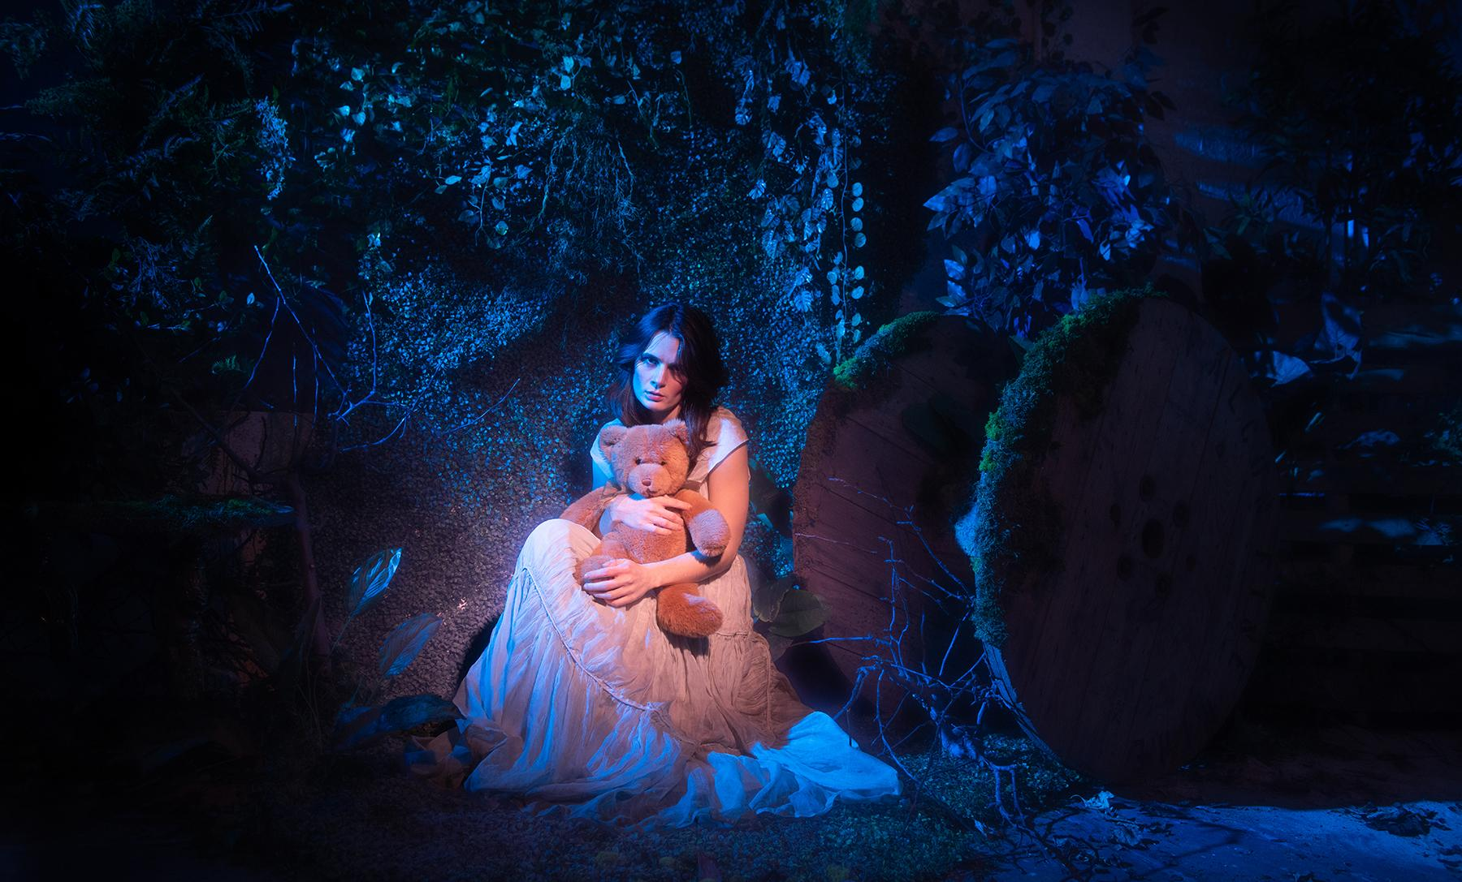 | Jaina Cipriano  Who is the Dreamer?  photograph in built environment  16.5 x 24.5 inches  $750
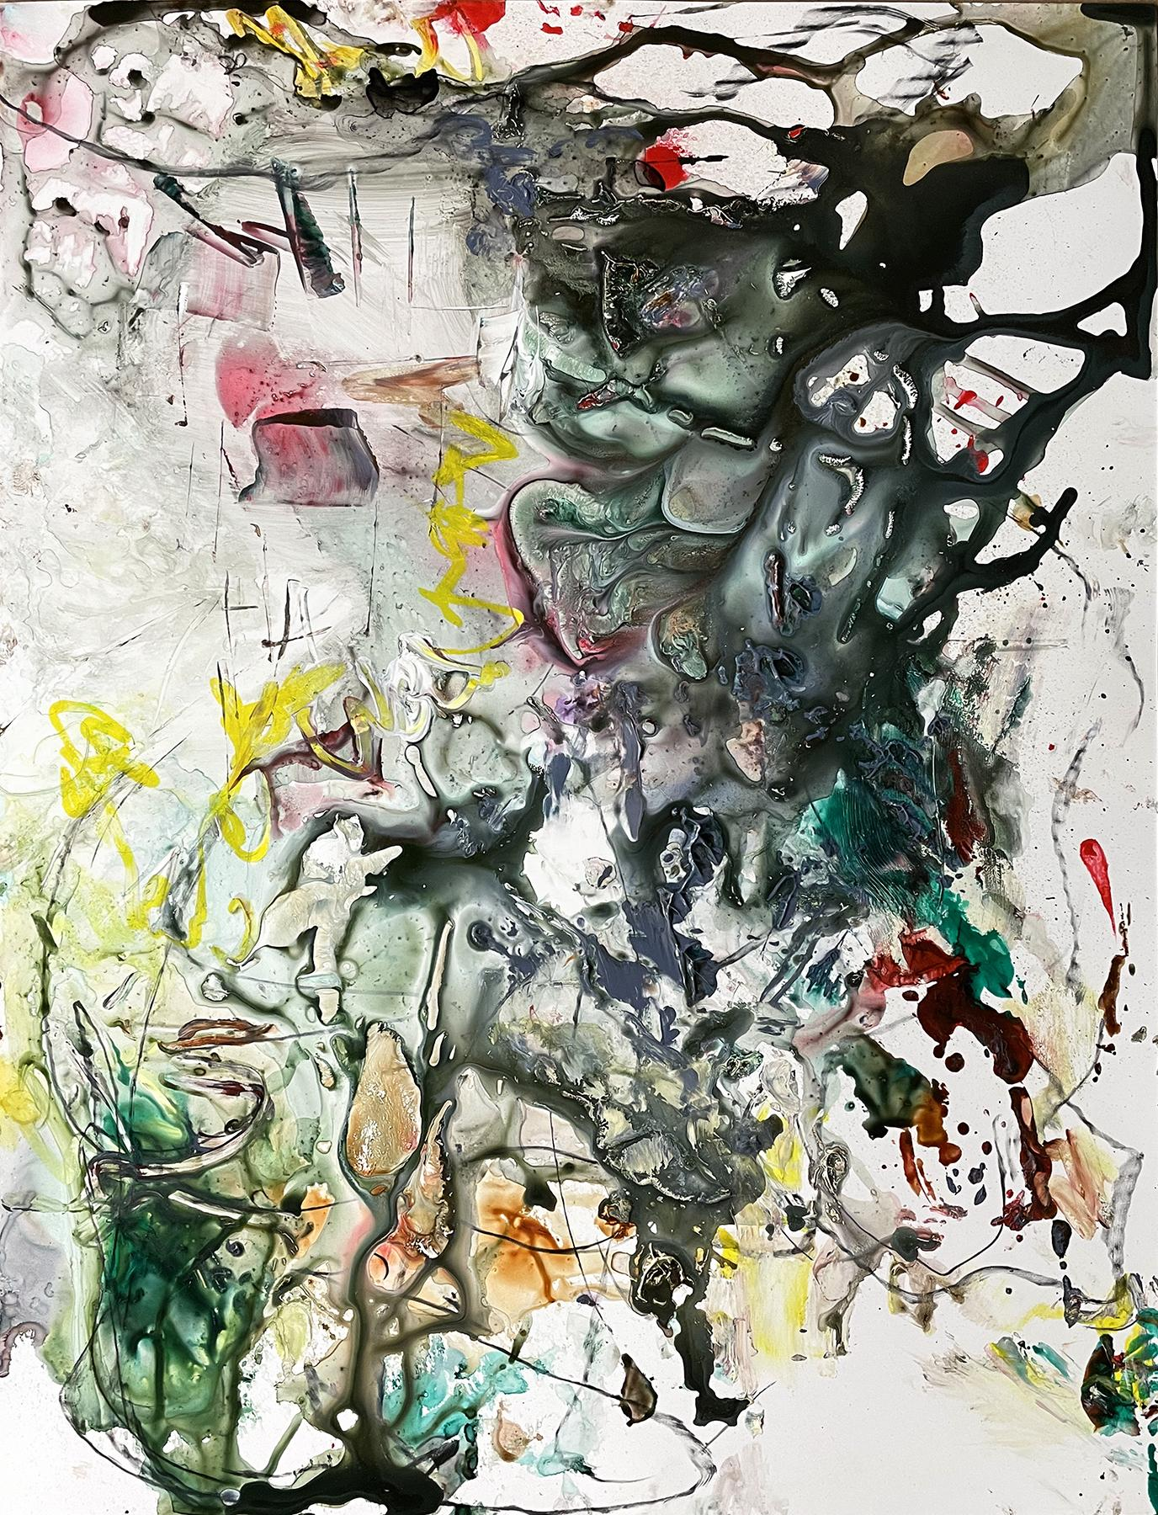 | Kathryn Shagas  Dreamscape  monotype, acrylic, drawing media on yupo  26 x 20 inches  $2200
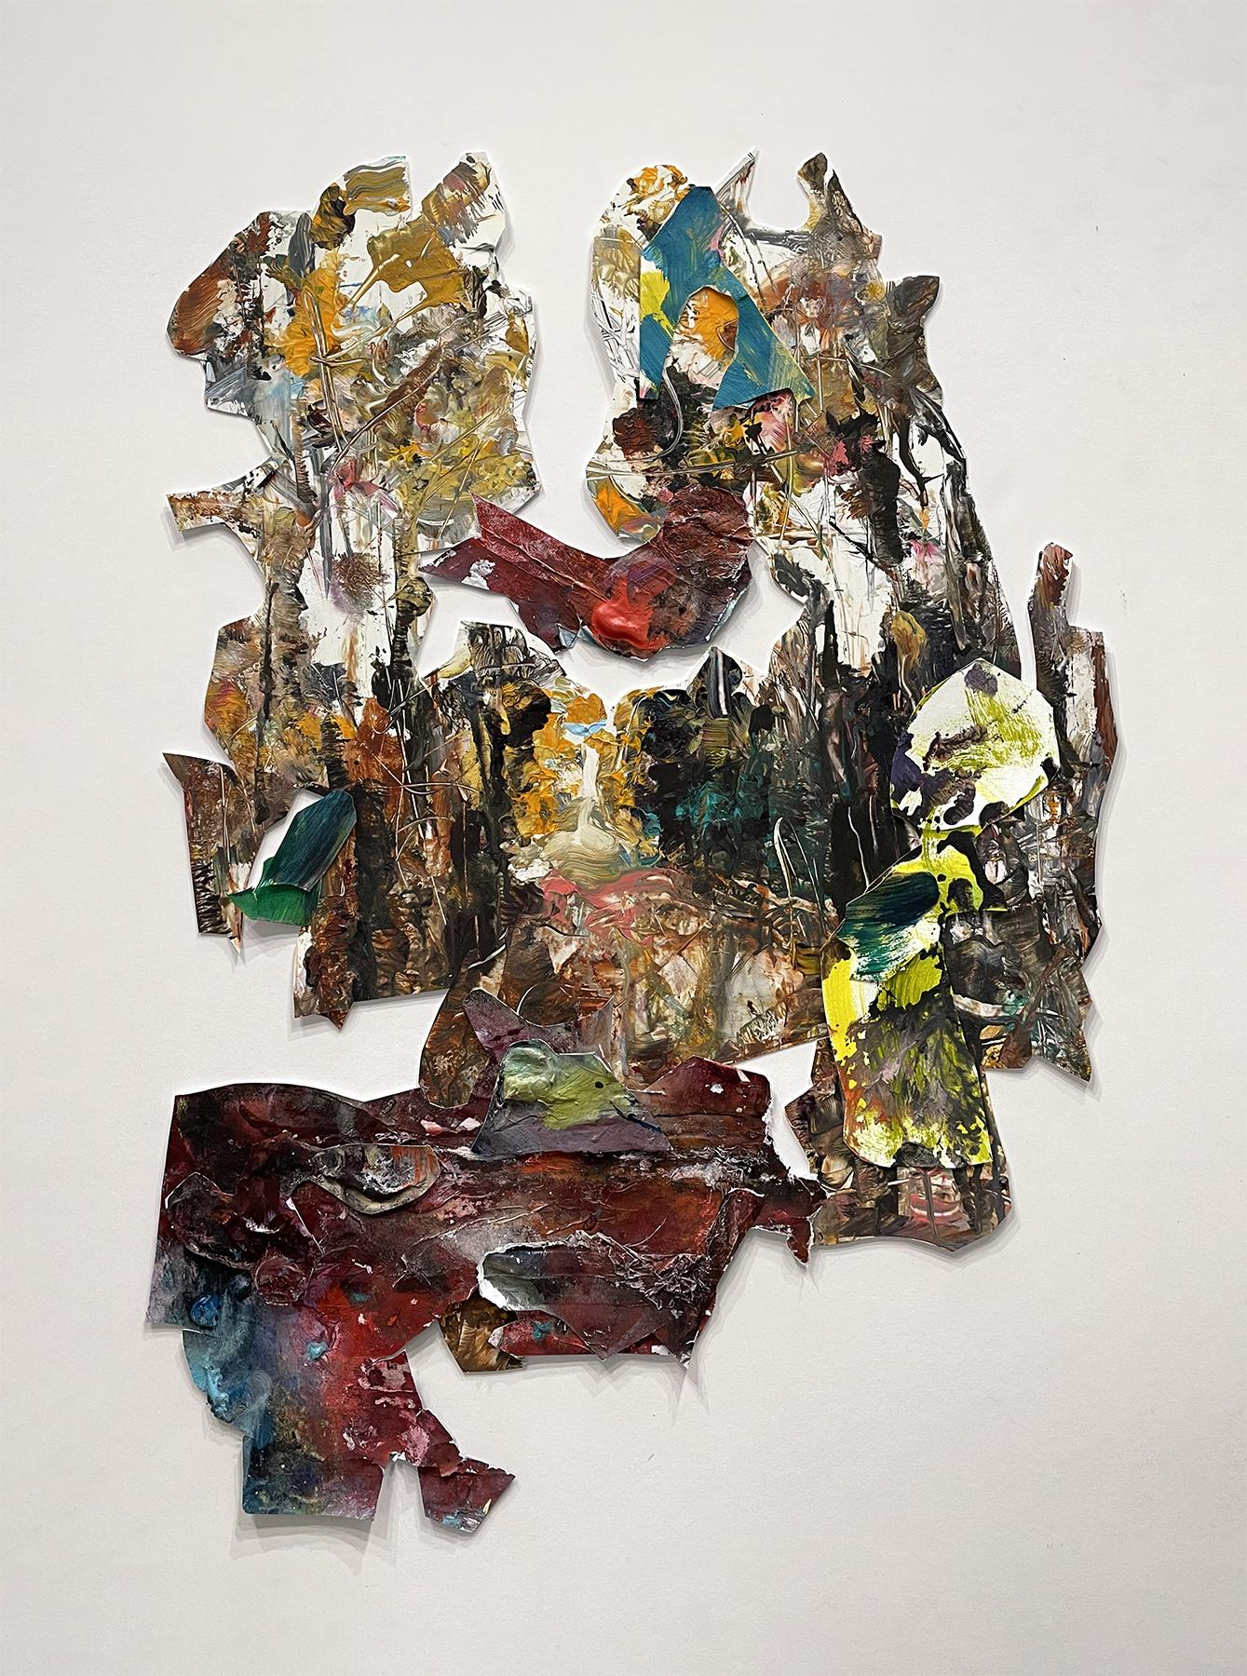 | Kathryn Shagas  Passages  painted paper freeform collage on wood  26 x 18.5 x .75 inches  $1600
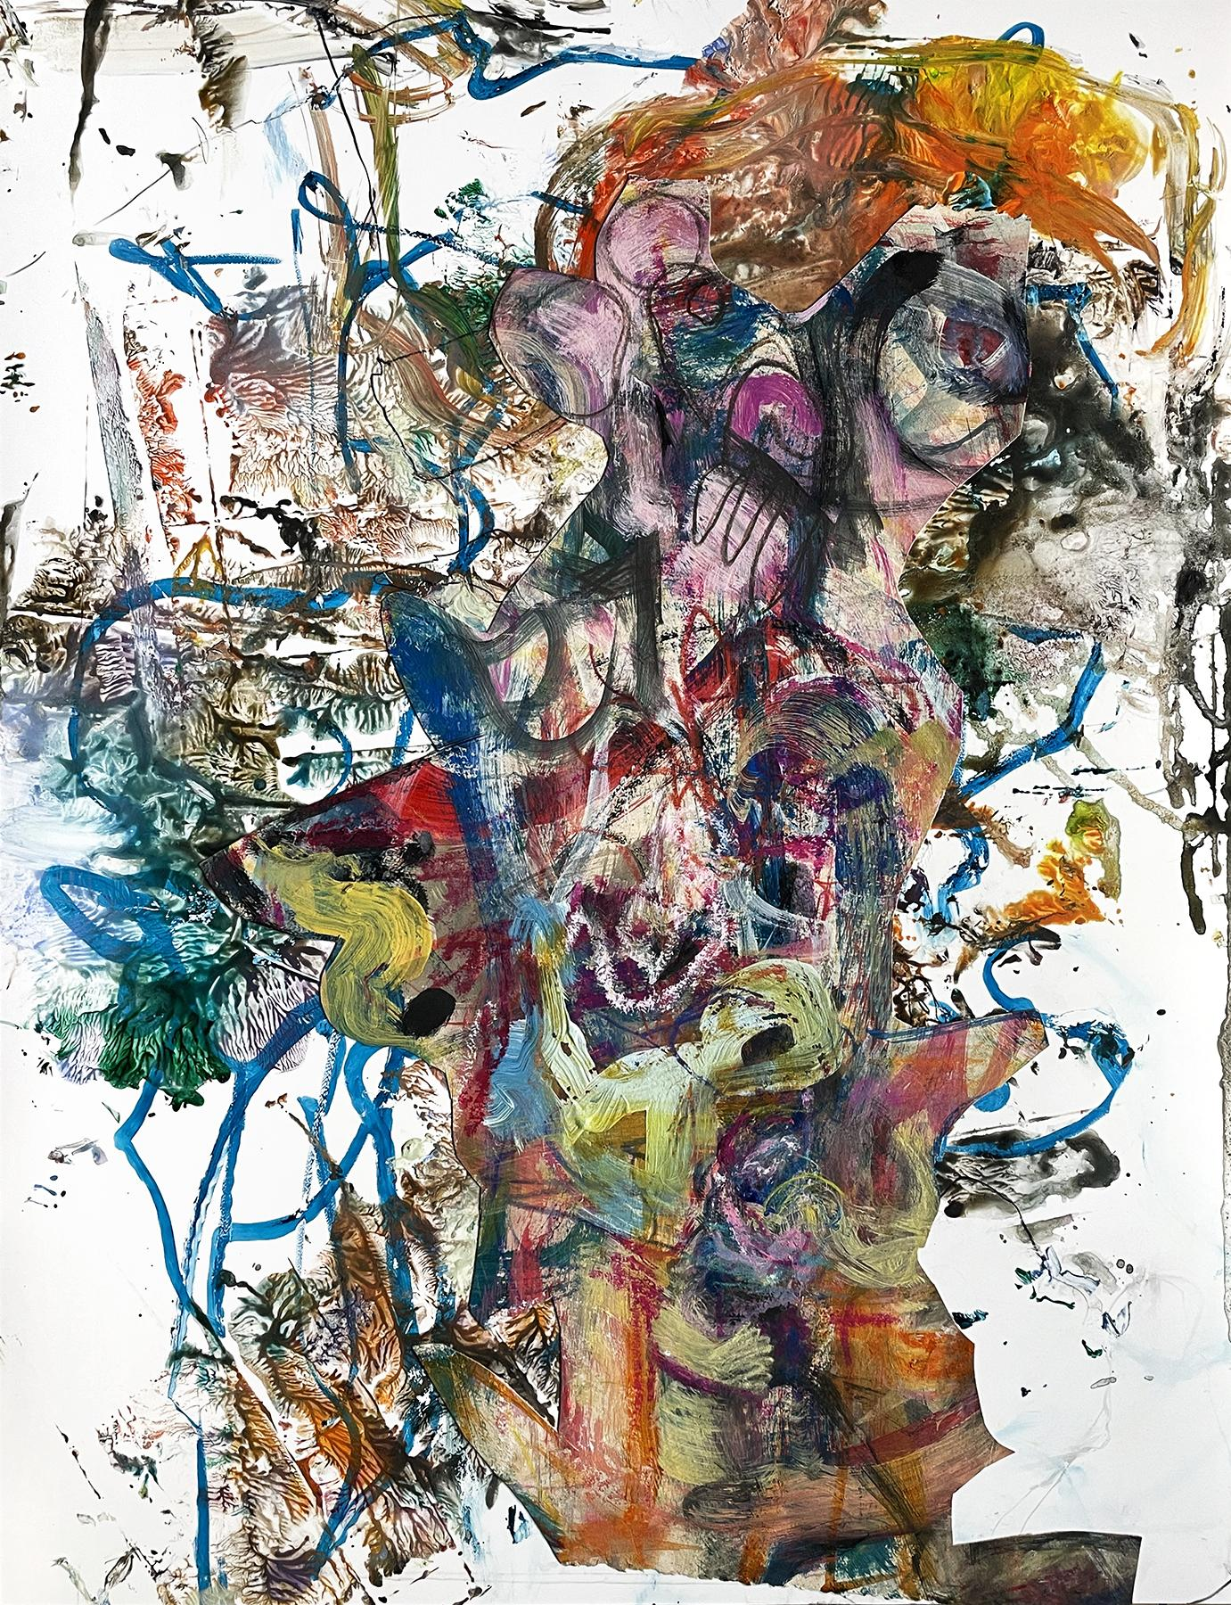 | Kathryn Shagas  Shimmy  monotype, acrylic, collage, drawing media on yupo  26 x 20 inches  $2200
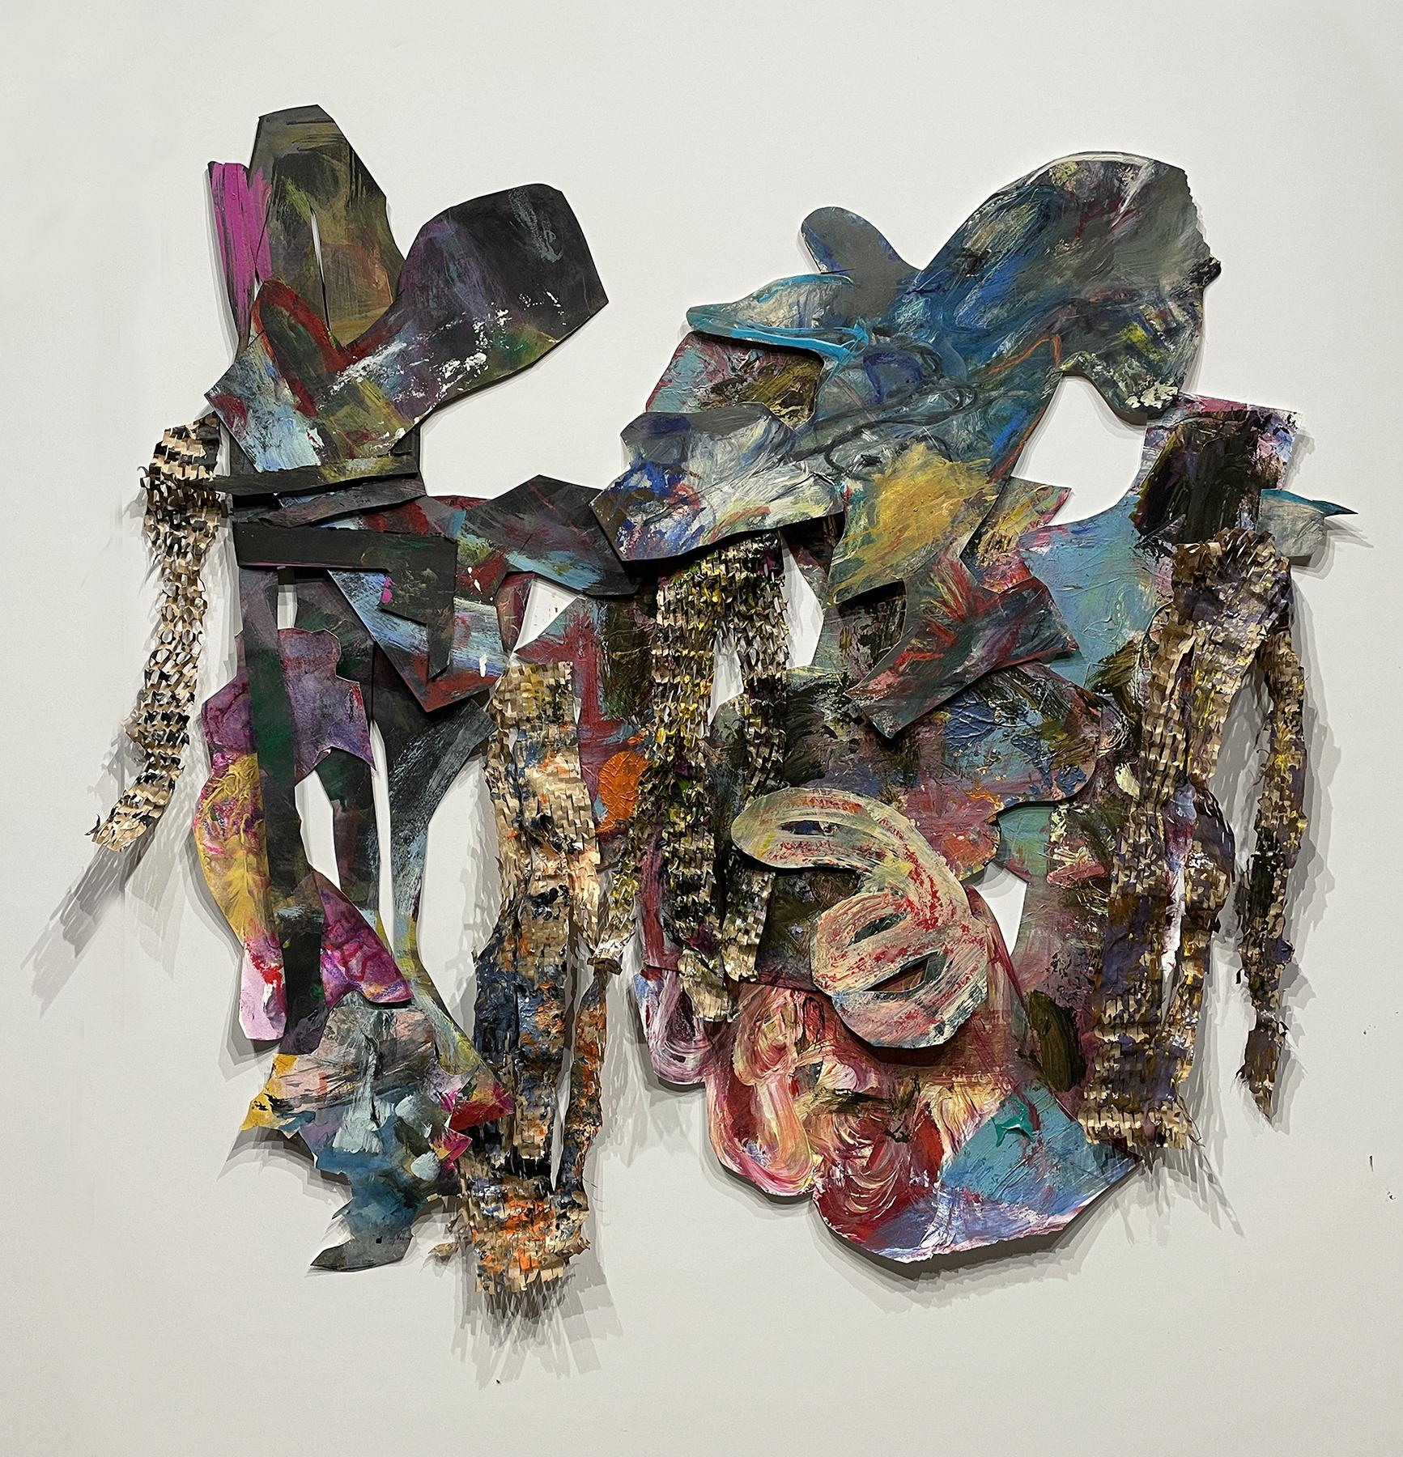 | Kathryn Shagas  Windward  painted paper freeform collage on wood  27.5 x 26.5 x 1.25 inches  $650
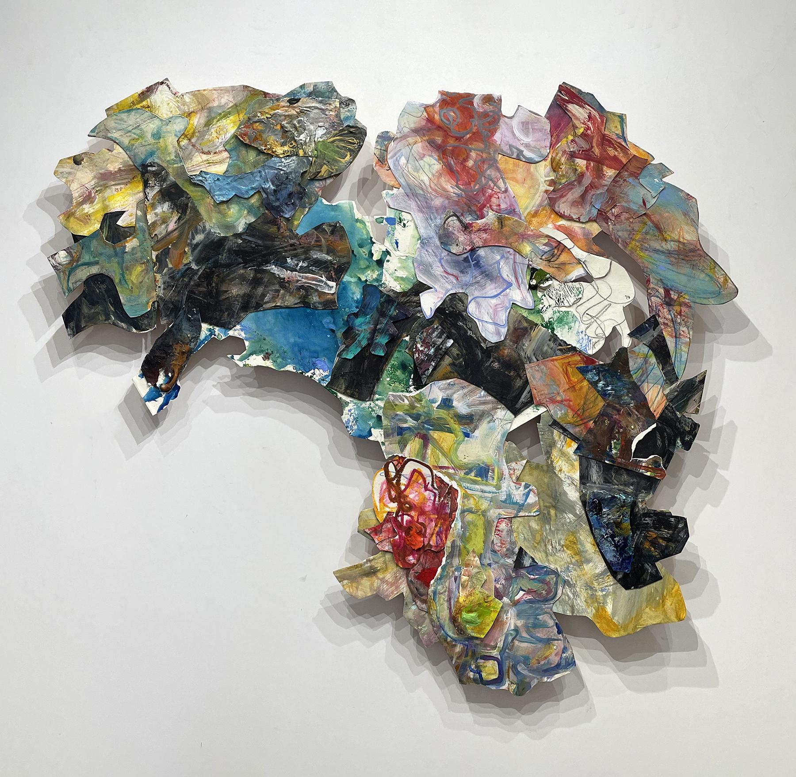 | Kathryn Shagas  Transitions  painted paper freeform collage on wood  36 x 40 x 1.25 inches  $3000

